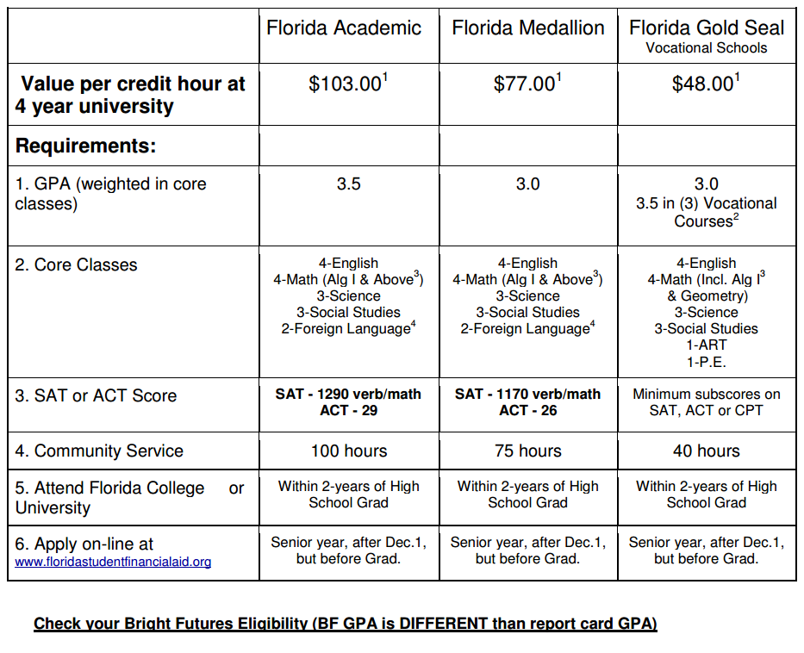
BRIGHT FUTURES REQUIREMENTS

Check your BF eligibility at
https://www.floridashines.org/CCRE/hs_accessbf.jsp

